

**Finding Name:** Implicit Any Index Errors Suppression.

|  |  |  |  |  |  |
| --- | --- | --- | --- | --- | --- |
| **Name** | **Team** | **Role** | **Project** | **Quality Assurance** | **Is this a re-tested Finding?** |
| Jaspriya Kaur | SCR | Senior Lead | Ontrack |  |  |
|  |  |  |  |  |  |

|  |
| --- |
| **Was this Finding Successful?** |
| Yes |

**Finding Description**

The finding pertains to the configuration of "suppressImplicitAnyIndexErrors" in the TypeScript file. Enabling this feature, while holding minor impact and unlikely occurrence, could lead to confusion in TypeScript's typing enforcement, potentially causing unexpected behavior or bugs. Although it won't directly obstruct regular activities or inflict critical damage, setting "suppressImplicitAnyIndexErrors" to false in tsconfig.json is recommended to ensure TypeScript properly flags accessing properties on objects lacking explicitly defined index signatures.

**Risk Rating**

Impact: Minor

Likelihood: Unlikely

|  |  |  |  |  |
| --- | --- | --- | --- | --- |
| **Impact values** | | | | |
| **Very Minor** | **Minor** | **Significant** | **Major** | **Severe** |
| Risk that holds little to no impact. Will not cause damage and regular activity can continue. | Risk that holds minor form of impact, but not significant enough to be of threat. Can cause some damage but not enough to impede regular activity. | Risk that holds enough impact to be somewhat of a threat. Will cause damage that can impede regular activity but will be able to run normally. | Risk that holds major impact to be of threat. Will cause damage that will impede regular activity and will not be able to run normally. | Risk that holds severe impact and is a threat. Will cause critical damage that can cease activity to be run. |

|  |  |  |  |  |
| --- | --- | --- | --- | --- |
| **Likelihood** | | | | |
| **Rare** | **Unlikely** | **Moderate** | **High** | **Certain** |
| Event may occur and/or if it did, it happens in specific circumstances. | Event could occur occasionally and/or could happen (at some point) | Event may occur and/or happens. | Event occurs at times and/or probably happens a lot. | Event is occurring now and/or happens frequently. |

**Business Impact**

The impact of the "suppressImplicitAnyIndexErrors" set to true is minor. It might lead to potentially confusing situations where TypeScript doesn't enforce strict typing, potentially leading to unexpected behaviour or bugs. However, it won't directly impede regular activity or cause critical damage to the application.

**Affected Assets**

This vulnerability affects the TypeScript configuration file of the application.

**Evidence**

**Step 1.** I manually found that vulnerability in Path: /home/kali/Doubtfire-deploy/Doubtfire-web/tsconfig.json

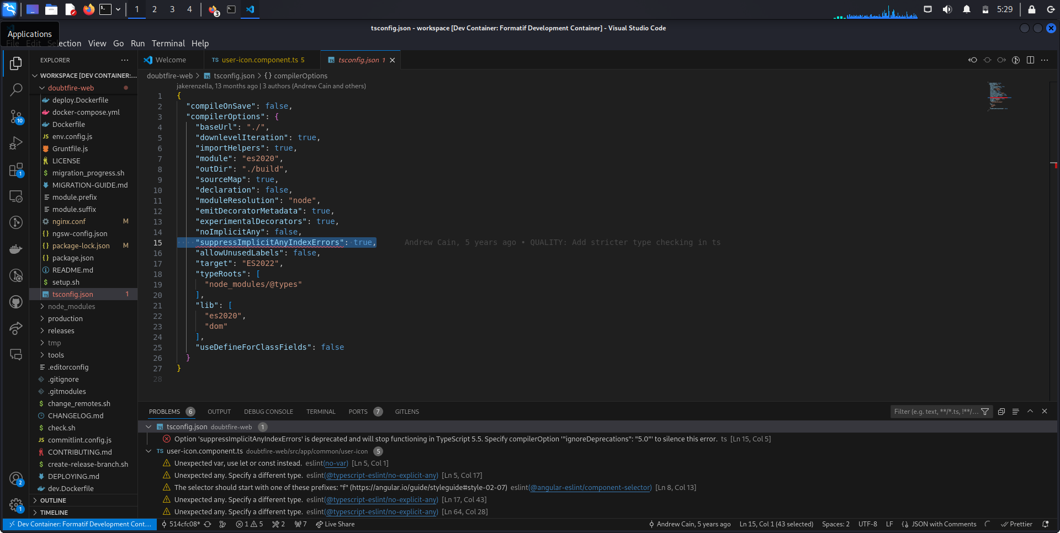

**Remediation Advice**

To mitigate this vulnerability, set "suppressImplicitAnyIndexErrors" to false in the TypeScript configuration file (tsconfig.json). Enabling this option ensures that TypeScript will give an error when trying to access properties on an object with an index signature that isn't explicitly defined.

**References**

[TypeScript: Documentation - tsc CLI Options (typescriptlang.org)](https://www.typescriptlang.org/docs/handbook/compiler-options.html" \l ":~:text=Compiler Options 1 CLI Commands Flag ... 2,Options Flag ... 4 Compiler Flags Flag )

**Contact Details**

Jaspriya Kaur

S222196102@deakin.edu.au

**Pen test Leader Feedback.**

The lead will provide feedback to enact on.